Curriculum Vitae (RESUME)
Last update: 10 March 2024 (1402/12/20)

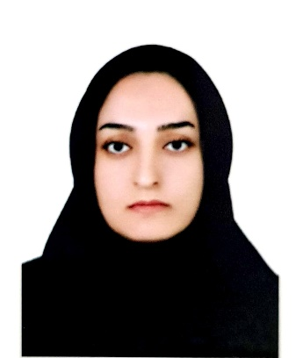

- Personal Information:
Name: Agrin Surname: Mohammadi
Master of Psychiatric Nursing
Date of Birth: 1993-08-12
Place of Birth: Marivan, IRAN
Nationality: Iranian
Affiliations:
Psychiatric nurse, Instructor, Faculty of Nursing and Midwifery, Kurdistan University of Medical Sciences, Sanandaj, Iran

Email: agrinmohammady.2013@gmail.com & Agrin.mohammady@muk.ac.ir
Phone: 00989187709226

- Education:
Degree | University | Field | Date
M.Sc. | Shiraz University of Medical Sciences | Psychiatric Nursing | 1400 (2022)
B.Sc. | Kurdistan University of Medical Sciences | Nursing | 1395 (2017)
- M.Sc. Thesis
- The Prevalence of Misophonia and Its Relationship with Obsessive-compulsive Disorder, Anxiety, and Depression in Undergraduate Students of Shiraz University of Medical Sciences: A Cross-Sectional Study.
- Employment date
  - Started working as a nurse in the ICU of Tohid Hospital on 28 February 1395 to 30 September 1397 and 1 February 1399 to 11 March 1400.
  - From 11 March 1400 until now; as a academic member in the Nursing Department, Faculty of Nursing and Midwifery, Kurdistan University of Medical Sciences.
- Executive positions
  - Faculty Accreditation Officer (16 April 1401 until now)
- Teaching experiences:
- Work with students of psychiatry department (nursing students)
- Teaching life skills (emergency medicine students)
- Publications:
- Shaygan M, Tehranineshat B, Mohammadi A, Foruhi Z. A National Survey of the Prevalence of Chronic Pain in Nursing Students and the Associated Factors. Investigación y Educación en Enfermería. 2022 Apr;40(1).
- Yektatalab S, Mohammadi A, Zarshenas L. The prevalence of Misophonia and its relationship with obsessive-compulsive disorder, anxiety, and depression in undergraduate students of Shiraz University of Medical Sciences: a cross-sectional study. International Journal of Community Based Nursing and Midwifery. 2022 Oct;10(4):259.

